APACHE AIRFLOW

Apache Airflow is an open-source platform developed by Airbnb and now part of the Apache Software Foundation. It is designed to programmatically author, schedule, and monitor workflows. Airflow enables users to define workflows as directed acyclic graphs (DAGs) using Python code, making the workflows dynamic, extensible, and version-controlled.
Components of Apache Airflow:
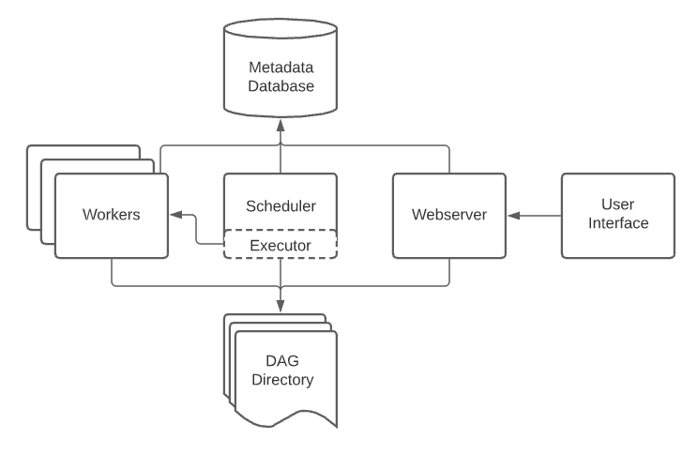
1. DAG (Directed Acyclic Graph)
A DAG is the foundation of any workflow in Airflow. It represents the workflow structure as a graph where:
- Nodes are individual tasks.
- Edges define dependencies between tasks.
- The graph must be acyclic, meaning it can't loop back to a previous task.
Key properties of a DAG:
- DAG ID: Unique identifier for each DAG.
- Start Date & Schedule Interval: When and how often the DAG should run.
- Default Arguments: Global parameters like retries, owner, and email alerts.

2. Operators
Operators determine what kind of work a task will perform. Each operator encapsulates logic for a specific type of job. Common types include:
- PythonOperator
Executes a Python function. Used for custom logic, data processing, API calls, etc.
- BashOperator
Executes a bash command/script. Useful for system-level tasks or script automation.
- EmailOperator
Sends emails as part of the workflow, often used for alerts or status updates.
- DummyOperator
Placeholder that does nothing. Useful for structuring or testing DAGs.
- BranchPythonOperator
Allows conditional branching by selecting a path based on a condition.
- SubDagOperator
Embeds a sub-DAG inside a parent DAG for better modularity and reuse.
3. Tasks
A task is an instance of an operator in a DAG. It represents a single unit of work.
- Tasks have attributes like task_id, retries, execution timeout, and trigger rules.
- Task dependencies are set using set_upstream() or >> / << operators.
- Tasks can have retry mechanisms, SLA monitoring, and custom logic.
Each DAG run results in a set of task instances that are independently executed and tracked.
4. Scheduler
The Scheduler is the brain of Airflow, responsible for:
- Reading DAG definitions at regular intervals.
- Determining which tasks are ready to run based on their schedule and dependencies.
- Creating task instances and placing them in the execution queue.
The scheduler runs in a continuous loop and interacts with the metadata database to determine task states.
5. Executor
The Executor handles the actual execution of tasks. It works alongside the scheduler to run tasks in parallel.
Common types of executors:
- SequentialExecutor
- LocalExecutor
- CeleryExecutor
- KubernetesExecutor
6. Web UI
Airflow provides a powerful, easy-to-use web interface for managing workflows.
Main features:
- DAG View: Visualize the structure and dependencies of workflows.
- Tree View: Monitor execution status of each task over time.
- Graph View: View task execution flow in a directed graph format.
- Logs: Access detailed logs for each task instance.
- Manual Controls: Trigger, pause, or clear DAG runs and tasks.
It helps developers, data engineers, and analysts interact with workflows without writing code.
7. Metadata Database
The metadata database is the central storage for all Airflow operations. It stores:
- DAG definitions and task instances
- DAG run statuses
- Task logs and execution times
- Scheduler and executor state
Supported backends:
- PostgreSQL
- MySQL
This database ensures persistence, state tracking, and coordination between components like the scheduler, web UI, and executor.
Key Functionalities of Apache Airflow
- Workflow Automation: Automates complex ETL/ELT pipelines and data engineering tasks.
- Scheduling: Supports cron-based and custom scheduling of workflows.
- Monitoring & Logging: Real-time monitoring, retry mechanisms, and detailed logs for debugging.
- Dynamic Pipeline Generation: DAGs are defined in Python, allowing for loops, conditionals, and other dynamic features.
- Scalability: Airflow supports distributed execution with Celery or Kubernetes executors.
- Extensibility: Easily integrate with cloud platforms (AWS, GCP, Azure), databases, and third-party tools using custom plugins and operators.
- Alerting: Supports email and Slack notifications for task failures or retries.

